ITTF World Team Table Tennis Championships London 2026
Ticketing Information
Tickets for the ITTF World Team Table Tennis Championships Finals London 2026 will be released in phases to ensure that supporters from around the world have a clear pathway to secure their seats.
Supporters eligible for priority access will be able to purchase tickets from 10:00 (UK time) on Monday 15 December until 23:59 (UK time) on Wednesday 17 December.
During this window, eligible audiences will also be able to take advantage of Early Bird pricing, with a 10% reduction available for a limited time.
Eligible supporters will receive a link to buy tickets via email shortly before the Priority Window opens. There will be separate links for tickets at the Copper Box Arena and OVO Arena Wembley, which are hosting different stages of the competition.
Ticket sales will open to the wider public at 10:00 (UK time) on Thursday 18 December. The Early Bird discount period will remain open until 23:59 (UK time) on Friday 16 January 2026.

Ticket prices

Stage 1b Copper Box Arena 28 April – 1 May 2026
56 teams will compete in 14 groups to determine the 24 teams who will progress to Stage 2. This stage excludes teams ranked 1-7 and the host nation. Stage 1b comprises of 8 sessions, with 2 sessions per day (9.30am-4pm and 4.30-11pm).
Category | Price per session
Adults | £15
Children | £5

Stage 1a OVO Arena Wembley 2 May – 3 May 2026
Teams ranked 1-7 plus the host nation will compete in two groups of four for seeding positions heading into Stage 2. There is no elimination in Stage 1a.
Date | Cat 1 | Cat 2 | Cat 3 | Cat 4
2 May  Session 9  9am-3.30pm | £70 | £40 | £35 | £25
2 May  Session 10  4pm-10.30pm | £70 | £40 | £35 | £25
3 May  Session 11  11.30am-3.30pm | £70 | £40 | £35 | £25
3 May  Session 12  4-8pm | £70 | £40 | £35 | £25
Child tickets are available in Categories 3 and 4, at 20% discount on prices above; Day Passes will also be available with a 5% saving on the combined ticket price total.
Stage 2 OVO Arena Wembley 4 May – 10 May 2026
Stage 2 includes action from the round of 32 through to the finals. There will be two sessions per day. There is a four-table arena on 4-6 May and a one-table arena from 7 May onwards.
4 & 5 May – Round of 32
6 May – Last 16
7 & 8 May – Quarter Finals
9 May – Semi Finals
10 May – Finals

Session | Cat 1 | Cat 2 | Cat 3 | Cat 4
4 May  Session 13  9am-3.30pm | £70 | £35 | £30 | £25
4 May  Session 14  4-10.30pm | £70 | £35 | £30 | £25
5 May  Session 15  9am-3.30pm | £70 | £30 | £20 | £15
5 May  Session 16  4-10.30pm | £70 | £30 | £20 | £15
6 May  Session 17  9am-3.30pm | £70 | £30 | £20 | £15
6 May  Session 18  4-10.30pm | £70 | £30 | £20 | £15
7 May  Session 19  9am-3.30pm | £80 | £40 | £35 | £20
7 May  Session 20  4-10.30pm | £80 | £40 | £35 | £20
8 May  Session 21  9am-3.30pm | £90 | £50 | £40 | £30
8 May  Session 22  4-10.30pm | £90 | £50 | £40 | £30
9 May  Session 23  9am-3.30pm | £100 | £65 | £55 | £35
9 May  Session 24  4-10.30pm | £100 | £65 | £55 | £35
10 May  Session 25  10am-2.30pm | £120 | £70 | £65 | £45
10 May  Session 26  3-8pm | £120 | £70 | £65 | £45
Child tickets are available in Categories 3 and 4, at 20% discount on prices above; Day Passes will also be available with a 5% saving on the combined ticket price total. Prices shown exclude booking platform fees and facility fees.

Important information
- Each day is made up of two sessions – you can buy tickets for each session you wish to attend, a day pass. Prices are the same for both sessions on any given day – day passes have a 5% discount on the combined price of two session tickets.
- The nature of team table tennis competition means the length of matches can vary. Advertised session finishing times may be subject to change .
- Booking and facility fees apply on all transactions
- For information about group bookings, click here
- Hospitality and premium ticketing options will become available at a later date

Venue seating guides

Copper Box Arena – Stage 1b

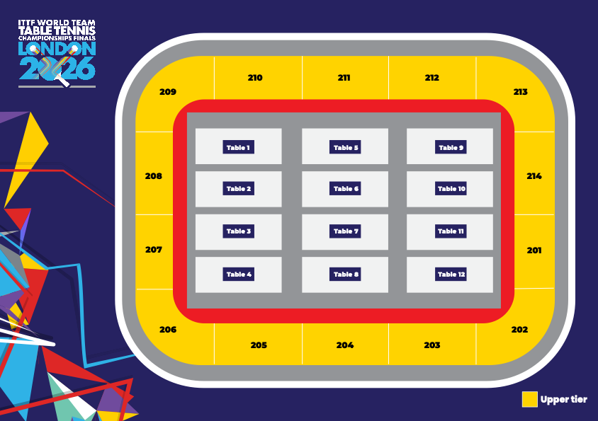

OVO Arena Wembley – Stage 1a & Stage 2

4 Table (2 May – 6th May)

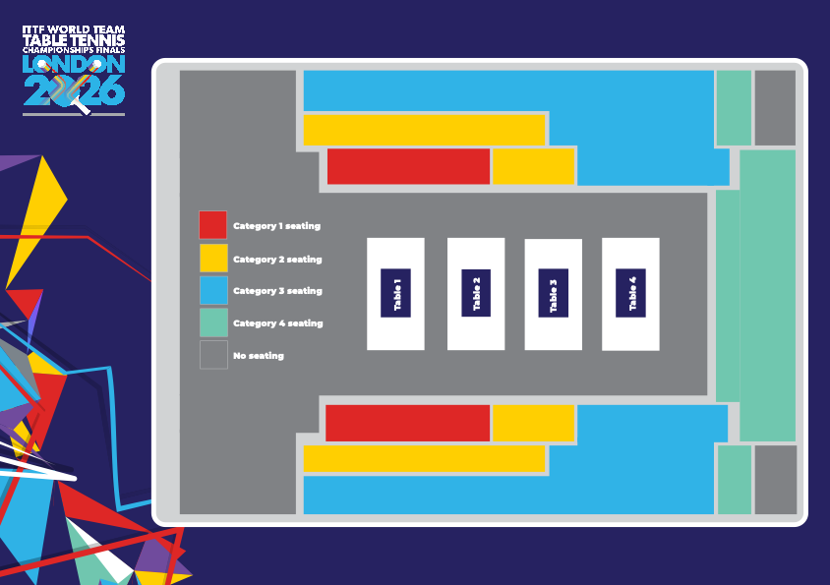

OVO Arena Wembley – Stage 2

1 Table (7 May – 10th May)

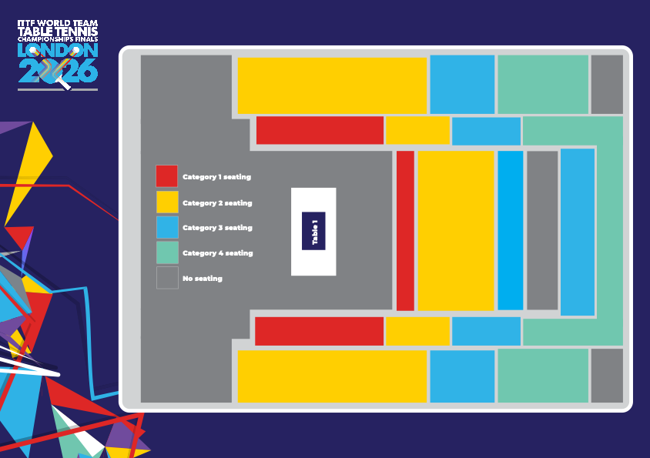

FAQs
- When do tickets go on sale?
Table Tennis England members will receive priority access to purchase tickets from 10am on Monday 15 December until 11.59pm on Wednesday 17 December.
Ticket sales will go on general sale from 10am on Thursday 18 December.
There is an earlybird discount period, with 10% off all prices, from 10am on Monday 15 December to 11.59pm Friday 16 January, 2026.
From Saturday 17 January, tickets will continue on general sale, but at the full prices.
- Who is eligible for the priority window?
Members of each qualified nation, WTT subscribers and selected partners will receive access to the priority window. Become a member of your national association to receive information and access to the priority window before 14th December.
- Are priority tickets guaranteed?
No. Tickets are subject to availability and are sold on a first-come, first served basis.
- Can I share my priority link publicly?
No. Priority links are for eligble audiences only and should not be shared publicly.
- What ticketing options are available?
Individual session ticket tickets and day passes will be available each day of the event.
For Stage 1b at the Copper Box Arena, a Season Pass will be available. This ticket type permits fans to access every session throughout Stage 1b.
For Stage 1a and 2 at OVO Arena Wembley an event pass will also be available. This will permit fans to access every session throughout Stage 1a and Stage 2.
Hospitality/Premium ticketing options will be available soon.
- Where are tickets on sale?
Tickets to Stage 1B the Copper Box Arena are via Ticketmaster. You will be able to buy session tickets, day passes or an event pass for Stage 1B.
Tickets to OVO Arena Wembley are via the AXS platform. A percentage of tickets to OVO Arena Wembley will also be available on Ticketmaster.
- How do I buy multiple session tickets across the event?
The Flex Package via AXS allows you to bundle session tickets across multiple dates and sessions into a single purchase.
- Why are tickets sold on both Ticket Master and AXS?
As the event spans across two venues. Each of these venues have their own respective ticketing partners.
- What is the earlybird discount?
Tickets bought between 10am on Monday 15 December to 11.59pm on Friday 16 January, 2026 have a 10% discount on advertised prices.
- Are the tickets for reserved seats?
Tickets at the Copper Box Arena are unreserved. For OVO Arena Wembley, you will receive a seat number.
- Can I buy a ticket for an entire day?
Yes, there is a day pass option. Both sessions on any given day are the same price. The day pass comes with a 5% discount on the combined cost.
You will receive confirmation by email immediately after purchase. Your digital ticket, which can be printed, will be received shortly before the event.
Spectator information will be sent out by email a few days before the event and will also be available online.
- Can I buy a ticket to the entire event?
Event passes options will be available.
An Event Season Ticket will be available covering Stage 1b at the Copper Box Arena.
An Event Pass will also be available for Stage 1a and Stage 2 (combined) at OVO Wembley Arena.
- Can I buy tickets for friends and family?
Yes, subject to ticket limits per transaction.
- Are accessible tickets available?
Yes. Accessible seating and companion tickets are available via the ticketing platforms.
- How do I book accessible tickets?
Follow the accessible booking instructions on Ticketmaster or AXS, or contact their customer support teams directly.
- Can I change or refund my tickets?
Ticket changes and refunds are subject to the terms and conditions of the ticketing platform used.
- What if I can’t find my tickets?
Check your confirmation email and ticketing account. If issues persist, contact Ticketmaster or AXS customer support.
- Who do I contact if I have a problem with my booking?
Contact the ticketing platform you booked through:
Ticketmaster support for Ticketmaster purchases
AXS support for AXS purchases
- Will tickets be available on the door?
Tickets may be available on the day, subject to availability. Advance booking is strongly recommended.
- Which nations are playing at each venue?
All teams other than the top seven seeds and England as host nation will play in Stage 1B at the Copper Box Arena, to decide which 24 teams will qualify to join the eight seeded teams at OVO Arena Wembley.
The top seven seeded teams, plus England as hosts, will play exclusively at OVO Arena Wembley.
The full list of qualified nations will be confirmed in the new year. Click here to see which teams qualified via continental championships. Click here to see which have been invited based on world rankings.
- What is the schedule?
Exact details of which teams are playing in which sessions will not be available until after the draw is made early in 2026.

