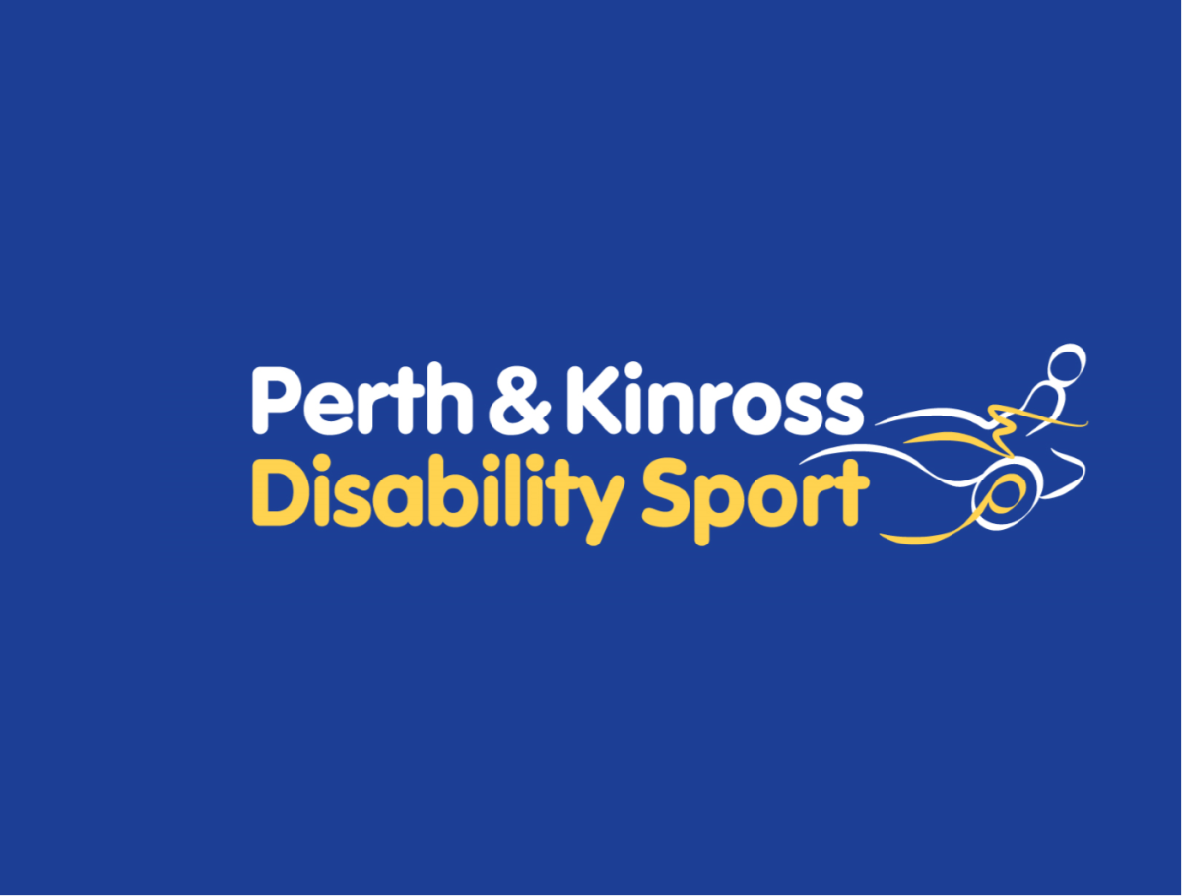
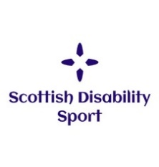
Perth & Kinross Disability Sport
Open Singles Table Tennis Championships 2023
with Saints Table Tennis Club
Sunday 21 May 2023 – 12am – 4pm
Bells Sports Centre, Hay Street, Perth
Closing Date for Entries 14 May 2023
Perth & Kinross Disability Sport, in partnership with Saints Table Tennis Club, Table Tennis Scotland and Scottish Disability Sport are delighted to invite entries from across Scotland to this year’s Perth & Kinross Disability Sport Table Tennis Championships. This is a single’s only competition and there is no cost to participate.
SCHEDULE:
- Registration will open at 11.15am and the championships will begin at 12pm sharp. The schedule and draw will depend on the number of entries and will be completed one week before the event. We aim to do a round robin format to ensure everyone gets multiple games before a knockout stage or final.
SECTIONS:
There will be Five sections of the competition.
- A - Open Class for Players who use a wheelchair.
- B - Open Class for Players with an ambulant Physical Disability
- C - Open Class for Players with a Learning Disability – Three Divisions based on player ability – Beginner, Intermediate and Performing

- Round robin matches will be played first to 11. Best of three sets. The finals will be best of five sets to 11.

ONLINE REGISTRATION:
Online registration is available by clicking on this link: Perth & Kinross Disability Sport Table Tennis Championships 2023 | Cognito Forms
If preferred, you can complete the form below and email it to Graeme@pkds.org.uk or by post to Graeme Doig, Perth & Kinross Disability Sport, Dewars Centre, Glover Street, Perth PH2 0TH
Perth & Kinross Disability Sport Table Tennis Championships Entry Form
Club Name: __________________ Contact Name: ________________ Contact email: _________________
Please indicate if you are happy to be included in any photos taken for partner social media platforms (end column)
Player Name | Email Address | Home Postcode | Date of Birth | Gender | Disability (LD, PD, WC) | Any additional info we need to be aware of and your experience in the sport | Photo consent
Example  Joe Bloggs | Joe.bloggs@bowling.com | ABC 123 | 01/01/2001 | M | LD | Club player | YES
Disability type LD: Learning Disability PD: Ambulant Physical Disability WC: Wheelchair
Perth and Kinross Disability Sport Table Tennis Championships
Players Code of Conduct

The aim of Perth & Kinross Disability Sport is to create a lively sporting environment, and to promote the spirit of the game, through the exclusion of unethical behaviour, which will not be tolerated.

Please:
- Treat all others as you would like to be treated, with integrity politeness and admiration.

- Practice, play and spectate within the spirit of the game.

- Help each other to learn new skills.

- Give respect to others – coaches, officials, other players, parents and volunteers who help organise/ officiate and play the sport.

- Accept final decisions from event referee, court umpires and officials.

- Do not direct verbal, physical, emotional abuse towards opponents/coaches/umpires/partners/event organisers/spectators.

- Arrive 15 minutes before the start of play to ensure adequate preparation and to be punctual on all occasions, inform event organisers of any injuries which cause you to withdraw from matches.

- Respect when officials are working and that their busy role in assisting with the event delivery may make them inaccessible at some times.

- Respect that the taking of photographs is to be carried out only with the appropriate accreditation and at times that are appropriate during the event or highlighted by the event organisers so as not disturbing competitors or officials.

Perth & Kinross Disability Sport Privacy Notice
Perth & Kinross Disability Sport is a “controller” of the personal information you provide us.
What We Need
When you provide information about yourself for events, courses, workshops or other opportunities, we will ask you for the following information.
- Contact details including name, address, telephone number, email address and date of birth;
- Details of your role in sport, e.g. coach, athlete, volunteer, official, parent, support staff;
- Equality information including age, disability or medical condition, employment information, ethnic group, religious belief, gender identity and sexual orientation.
Why we need your personal information
Contractual purposes
We need to collect personal information in order to manage attendance and participation. We will use this information to:
- Provide you with services such as training activities;
- Administer your attendance;
- Process awards and qualifications
- Send you communications in relation to opportunities we think may interest you.
If you do not provide all of the personal information we request then this may affect our ability to offer you services and benefits.
Legitimate purpose
We also process personal information in order to:
- Promote and encourage participation in disability sport by sending communication about forthcoming opportunities. Our events may be photographed or filmed and information captured in this way may be used for promotional and education purposes. You will always be given the option to refuse this;
- Provide opportunities and competition in disability by managing entries for events and checking your personal information to ensure you are participating at an appropriate level;
- Monitor and develop participation in disability sport by monitoring engagement and participation and , on occasion, inviting participants to take part in surveys for research and development purposes;
- Develop and maintain qualifications and awards, including sending communications to inform you of forthcoming courses, renewal requirements and to verify that you have completed any mandatory training requirements;
- Respond to and communicate with participants regarding questions, comments, support needs or complaints in relation to disability sport.
Where we process your personal information in pursuit of our legitimate interests, you have the right to object to us using your personal information for these purposes. If you wish to object to any of these, please contact Perth & Kinross Disability Sport on 07999544549, email Graeme@pkds.org.uk or write to us at Dewars Centre, Glover Street, Perth PH2 0TH

Legal obligations
We are under a legal obligation to process certain personal information for the purpose of complying with:
- The Protection of Vulnerable Groups (Scotland) Act 2007 to check that our coaches and volunteers are able to undertake regulated work with children and vulnerable adults;
- Our sportscotland regulatory requirements to report on size, achievements and profile;
- The equality Act 2010, which requires us to process personal information to make reasonable adjustments where necessary.
Equality monitoring requirements
We are required by sportscotland to use personal information relating to equality for monitoring purposes.
We will process such personal information through aggregated and anonymised reports to identify and keep under review equality of opportunity or treatment of groups of people, to promote or maintain equality within disability sport.
Other uses of personal information
We may ask you if we can process your personal information for additional purposes. If so, we will provide you with additional information on how we will use your information.
Who we share your personal information with
If your personal information is included in any images or videos we take, we may share this with event or project partners or governing bodies, including sportscotland, for promotional purposes.
We may be required to share personal information with statutory or regulatory organisations such as Disclosure Scotland or Police Scotland.
We may also share personal with our professional and legal advisors on order to take advice.
Where we share personal information with third parties, we will only share the personal information strictly required for the specific purposes and will take reasonable steps to ensure that recipients shall only process the disclosed personal information in accordance with those purposes.
We may employ contractors to process personal information. Such contractors are subject to written contractors only process that information under our instructions, to process and to abide by the restrictions of existing legislation on data protection.
How long we keep your personal information
We will only keep your personal information for as long as necessary or for as long as we believe you maintain an interest in disability sport.
We will keep certain information for longer in order to confirm your identity.
Your rights
You can exercise any of the following rights by contacting Perth & Kinross Disability Sport on 07999544549, email Graeme@pkds.org.uk or write to us at Dewars Centre, Glover Street, Perth PH2 0TH:
- The right to request access to the personal information we hold about you by making a “subject access request”
- The right to have personal information corrected or completed;
- The right to request that we restrict the processing of your personal information for specific purposes;
- The right to request us to delete your personal information.
Any requests received by Perth & Kinross Disability Sport will be considered under data protection legislation. If you remain dissatisfied, you have a right to raise a complaint with the information commissioner’s office at www.ico.org.uk

