TOURNAMENT REGULATIONS

- The current laws of Table Tennis and the Rules & Regulations of the ITTF and TTS will apply.
- Competitors must be fully affiliated members of Table Tennis Scotland.
- Qualification rounds for singles events will be by groups, except at the discretion of the Organising Committee.
- All ties shall be the best of 5 games and 11 points up except the Men's & Ladies' singles finals, which shall be the best of 7 games.
- Completed entry forms to be emailed to Cynthia.robinson@tabletennisscotland.co.uk
by Tuesday 12th October 2021. Payment by BACS to Sort Code 83-21-08 Account 00255725
- If it is necessary to restrict entries, this will be done on the basis of "last in first out".
- The Tournament Committee will make the draw on a convenient date.
- Junior Competitors must be born 2002 or later.
- Cadet Competitors must be born 2005 or later.
- Minor Competitors must be born 2007 or later.
- All competitors will be required to umpire. Failure to do so when asked will result in disqualification
- No expenses will be paid to any competitor.
- Entry to the Championships implies that the competitor may undergo drugs testing.
- Any competitor taking part in gambling at the Championships shall be liable to immediate disqualification and eviction from the premises. Any such disqualification/eviction shall be reported to Table Tennis Scotland.
- Play shall be on Butterfly tables with Butterfly nets and posts. 40mm white plastic balls will be used.
- When called to the table, players will have 2 minutes to appear knock-up and start the match.
- Completion and submission of this entry form signifies agreement by the entrant to ALL conditions of the tournament.
- ITTF dress and racquet regulations will apply. Replica football kit is not permitted.
- Play will commence at 9.00 a.m.
- Changing, shower, and car parking facilities are available at the centre. (Subject to Covid Protocols)

PRIZES
MENS SINGLES Winner £300, Runner up £150 Losing Semi- Finalists £50 each
LADIES SINGLES Winner £200, Runner up £100 Losing Semi-Finalists £25 each
MEN'S DOUBLES Winners £50 each, Runners up £25 each
LADIES' DOUBLES Winners £30 each, Runners up £20 each
MIXED DOUBLES Winners £30 each, Runners up £15 each

TOTAL PRIZE FUND: £1240

TROPHIES will be awarded to the Winners & Runners up of the junior, cadet and minor events.

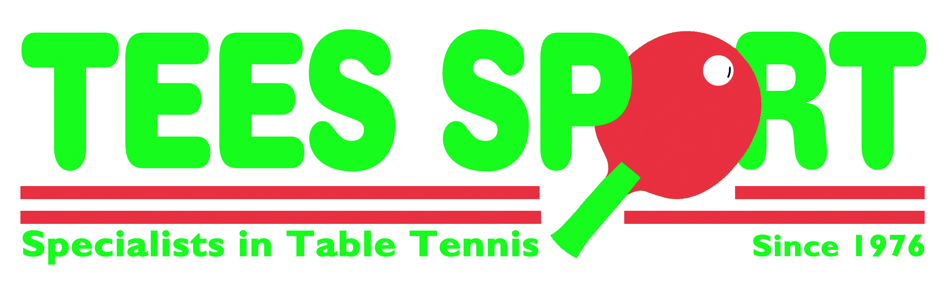

SCOTTISH NATIONAL CHAMPIONSHIPS

Saturday 23rd & Sunday 24th October 2021
Start Time 9.00 am
Bell’s Sports Centre, Perth, PH1 5HS Telephone 01738 492462

To be completed in BLOCK LETTERS and forwarded by email to:

Cynthia.robinson@tabletennisscotland.co.uk

ENTRIES RECEIVED WITHOUT FEES WILL NOT BE ACCEPTED
TELEPHONE ENTRIES WILL NOT BE ACCEPTED
CLOSING DATE TUESDAY 12th OCTOBER 2021

EVENT | PARTNER | FEE | ENCL.
Men's Singles Sat | ------------------- | £15.00
Men's Doubles Sat |  | £7.00 ea.
Ladies Singles Sat | ------------------- | £15.00
Ladies' Doubles Sat |  | £7.00 ea.
Mixed Doubles Sat |  | £7.00ea.
Junior Boys (U18) Sun | No Minors | £10.00
Junior Girls (U18) Sun | No Minors | £10.00
Cadet Boys (U15) Sun | -------------------- | £10.00
Cadet Girls (U15) Sun | -------------------- | £10.00
Minor Girls (U13) Sun | ---------------------- | £8.00
Minor Boys (U13) Sun | -------------------- | £8.00
Junior Boys Doubles Sun |  | £4.00 ea.
Junior Girls Doubles Sun |  | £4.00 ea.
Administration & Ranking Levy |  |  | £5.00
Total Due |  |  | £
Payment should be made by BACS to Table Tennis Scotland,
Sort Code 83-21-08 Account No. 00255725 showing players name as reference
NAME: ____________________________________ CLUB: _________________________________
ADDRESS: _____________________________________________________________________
E-MAIL _____________________________________________________________________
TEL NO: ____________________________ MOBILE________________________________
LEAGUE: ____________________________ AFFILIATION NO: _________________________

Date of Birth (Juniors, Cadets & Minors) ____________PLACE OF BIRTH (if not in Scotland): ____________

IF NOT BORN IN SCOTLAND HOW MANY YEARS HAVE YOU LIVED IN SCOTLAND? _____BRITISH PASSPORT_____YES/NO

