TOURNAMENT REGULATIONS

- The current laws of Table Tennis and the Rules & Regulations of the ITTF and TTS will apply.
- Competitors must be fully affiliated members of Table Tennis Scotland.
- Qualification rounds for singles events will be by groups, except at the discretion of the Organising Committee.
- All ties shall be the best of 5 games and 11 points up except the Men's & Ladies' singles finals, which shall be the best of 7 games.
- Completed entry forms and fees to be sent to TTS, Caledonia House, South Gyle, Edinburgh EH12 9DQ by Monday 18th February 2019. Cheques to be made payable to Table Tennis Scotland.
- If it is necessary to restrict entries, this will be done on the basis of "last in first out".
- The Tournament Committee will make the draw on a convenient date.
- Junior Competitors must be born 2001 or later.
- Cadet Competitors must be born 2004 or later.
- Minor Competitors must be born 2006 or later.
- All competitors will be required to umpire. Failure to do so when asked will result in disqualification
- No expenses will be paid to any competitor.
- Entry to the Championships implies that the competitor may undergo drugs testing.
- Any competitor taking part in gambling at the Championships shall be liable to immediate disqualification and eviction from the premises. Any such disqualification/eviction shall be reported to Table Tennis Scotland.
- Play shall be on Butterfly tables with Butterfly nets and posts. 40mm white plastic balls will be used.
- When called to the table, players will have 2 minutes to appear knock-up and start the match.
- Completion and submission of this entry form signifies agreement by the entrant to ALL conditions of the tournament.
- ITTF dress and racquet regulations will apply. Replica football kit is not permitted.
- Play will commence at 9.00 a.m.
- Changing, shower, and car parking facilities are available at the centre.

PRIZES
MENS SINGLES Winner £300, Runner up £150 Losing Semi- Finalists £50 each
LADIES SINGLES Winner £200, Runner up £100 Losing Semi-Finalists £25 each
MEN'S DOUBLES Winners £50 each, Runners up £25 each
LADIES' DOUBLES Winners £30 each, Runners up £20 each
MIXED DOUBLES Winners £30 each, Runners up £15 each

TOTAL PRIZE FUND: £1240

TROPHIES will be awarded to the Winners & Runners up of the junior, cadet and minor events.

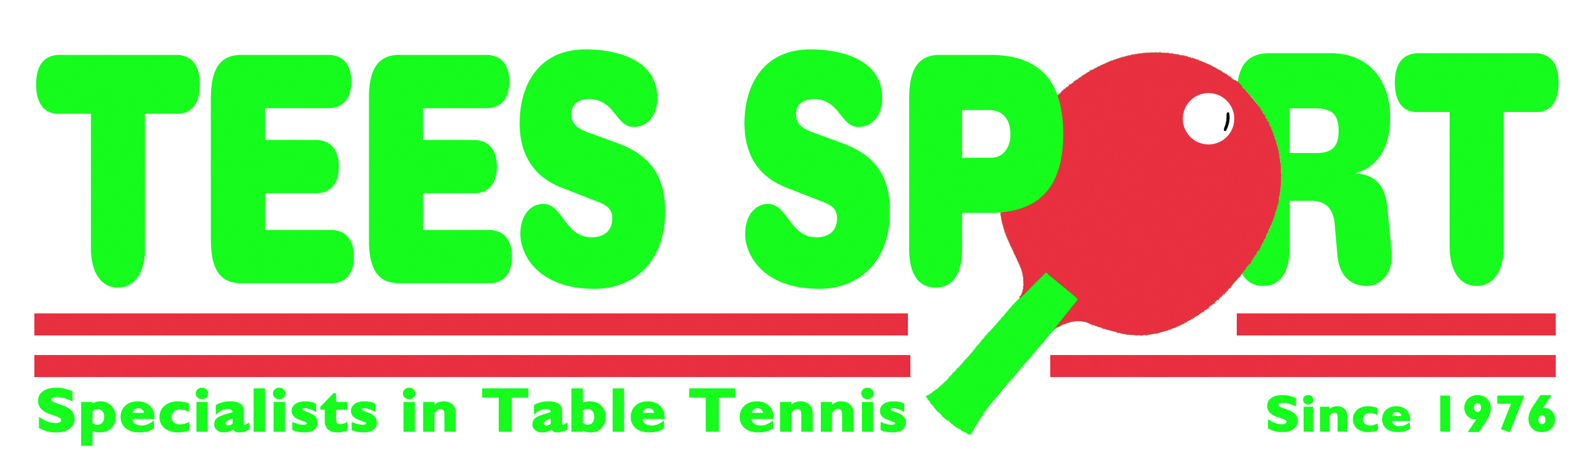

SCOTTISH NATIONAL CHAMPIONSHIPS
Saturday 2nd &Sunday 3rd March 2019
Start Time 9.00 am
Bell’s Sports Centre, Perth, PH1 5HS Telephone 01738 492462

To be completed in BLOCK LETTERS and forwarded with remittance to:

TTS, CALEDONIA HOUSE, SOUTH GYLE, EDINBURGH EH12 9DQ

ENTRIES RECEIVED WITHOUT FEES WILL NOT BE ACCEPTED
TELEPHONE ENTRIES WILL NOT BE ACCEPTED
CLOSING DATE MONDAY 18th February 2019

EVENT | PARTNER | FEE | ENCL.
Men's Singles Sat | ------------------- | £15.00
Men's Doubles Sat |  | £7.00 ea.
Ladies Singles Sat | ------------------- | £15.00
Ladies' Doubles Sat |  | £7.00 ea.
Mixed Doubles Sat |  | £7.00ea.
Disability Singles Sat |  | £10.00
Junior Boys (U18) Sun | No Minors | £10.00
Junior Girls (U18) Sun | No Minors | £10.00
Cadet Boys (U15) Sun | -------------------- | £10.00
Cadet Girls (U15) Sun | -------------------- | £10.00
Minor Girls (U13) Sun | ---------------------- | £8.00
Minor Boys (U13) Sun | -------------------- | £8.00
Junior Boys Doubles Sun |  | £4.00 ea.
Junior Girls Doubles Sun |  | £4.00 ea.
Administration & Ranking Levy |  |  | £5.00
Total Due |  |  | £

Payment may be made by cheque to Table Tennis Scotland or
Online Bank Transfer to Account No. 00255725 – Sort Code 83-21-08
NAME: ____________________________________ CLUB: _________________________________
ADDRESS: _____________________________________________________________________
E-MAIL _____________________________________________________________________
TEL NO: ____________________________ MOBILE________________________________
LEAGUE: ____________________________ AFFILIATION NO: _________________________

Date of Birth (Juniors, Cadets & Minors) ____________PLACE OF BIRTH (if not in Scotland): ____________

IF NOT BORN IN SCOTLAND HOW MANY YEARS HAVE YOU LIVED IN SCOTLAND? ________BRITISH PASSPORT YES/NO

