North Ayrshire Open 2018 St Matthews Academy, Saltcoats, KA21 5NT

September 1st  September 2nd | Senior Events Junior Events | Play commences at 9.30am  Closing Date – August 24th

Prize Money | Winner | Runner Up | Semi Finalists
Men’s Singles | £200 | £100 | £25
Women’s Singles | £100 | £50
Open Doubles | £60 per team | £30 per team
 |  | Total | £590

Prize Money, Vouchers & Gifts worth over £1000
North Ayrshire Open 2018 - Tournament Regulations & Information
The current laws of table tennis and the current rules & regulations of the ITTF & TTS will apply
Qualification rounds for singles events will be by groups of 4 except in certain circumstances
All matches will be the best of 5 games & up to 11 points
The tournament committee will make the draw on Monday 27th August
No expenses will be paid to any competitor
All competitors will be required to umpire, failure to do so could result in disqualification Changing rooms, Showers, Catering & Car park facilities will be available at the centre Play shall take place on Butterfly & Joola tables
Joola Flash 3* Balls will be used in all matches
When called to the table, players will have 2 minutes to appear, knock up and start the match
Junior competitors must be born 2001 or later
Cadet competitors must be born 2004 or later
Minor competitors must be born 2006 or later
U11 competitors must be born 2008 or later
Competitors in the veterans event must have been born before 1st January 1963
Completion & submission of entry form signifies agreement by entrant to conditions of tournament Closing Date is Friday 24th August , entries received without fees will not be accepted
Events where prize money is not stated, trophies and or vouchers will be given out to winners & r-up
Competitor can enter a maximum of 2 singles events & the doubles event per day

Supported by

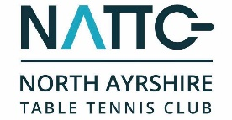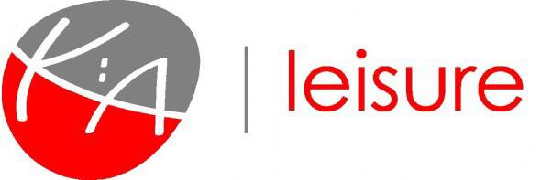

Full Name |  | Address
DOB |  | Post Code
Telephone |  | Mobile (Optional)
Club |  | Email Address
Signature |  | Date

Saturday 1st Senior Events | Fee | Enclosed
Men’s Singles | £10
Ladies Singles | £10
Open Band 1 Singles | £8
Open Band 2 Singles | £8
Over 55’s Mixed Singles | £8
Standing Disability | £8
Open Doubles (include partners name) | £5
 | Partner ___________________

Sunday 2nd Junior Events | Fee | Enclosed
Junior Boys (u18) | £9
Junior Girls (u18) | £9
Cadet Boys (u15) | £9
Cadet Girls (u15) | £9
Minor Boys (u13) | £7
Minor Girls (u13) | £7
Under 11’s Mixed | £7
Open Junior Doubles (include partners name) | £5

 | TTS 365 Affiliation Number | __________________
 | Country affiliated to if not Scotland | __________________
Table Tennis 365 Ranking Levy | £3 (Applicable to all players) | £3
 | TOTAL ENTRY FEE COST | __________________

